

Lab Report

SUBMITTED TO

Azizul Hakim

Lecturer

Department of Computer Science and Engineering

Faculty of Science and Information Technology

Daffodil International University

SUBMITTED BY

Name: Md. Anisur Rahman Rony

ID: 162-15-7880

Section: E

Course Title: Computer Networks Lab

Course Code: CSE 314

Department: Computer Science & Engineering

Experiment-3

Title: “Dynamic RIP Routing Configuration”

Objective: To learn how to configure router dynamically RIP. That means dynamic rip router configuration.

Tools: Genetic Router-PT, Switches 2950-24, End devices, Copper Straight-Through cable, Serial DCE cable, CISCO Packet Tracer 7.1.1.

Screenshots of Dynamic RIP Router Configuration

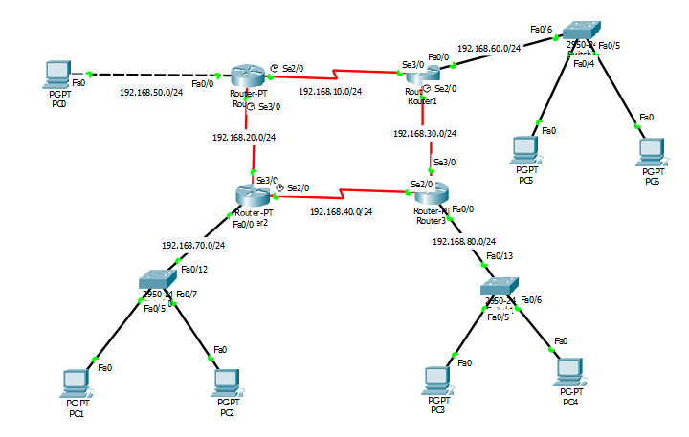

CLI Command for Dynamic RIP Router Configuration

Router 0

--- System Configuration Dialog ---

Would you like to enter the initial configuration dialog? [yes/no]: no

Press RETURN to get started!

Router>en

Router#conf t

Enter configuration commands, one per line. End with CNTL/Z.

Router(config)#int se2/0

Router(config-if)#ip add 192.168.10.1 255.255.255.0

Router(config-if)#clock rate 64000

Router(config-if)#no shut

%LINK-5-CHANGED: Interface Serial2/0, changed state to down

Router(config-if)#ex

Router(config)#int se3/0

Router(config-if)#ip add 192.168.20.1 255.255.255.0

Router(config-if)#clock rate 64000

Router(config-if)#no shut

%LINK-5-CHANGED: Interface Serial3/0, changed state to down

Router(config-if)#ex

Router(config)#int fa0/0

Router(config-if)#ip add 192.168.50.1 255.255.255.0

Router(config-if)#no shut

Router(config-if)#

%LINK-5-CHANGED: Interface FastEthernet0/0, changed state to up

%LINEPROTO-5-UPDOWN: Line protocol on Interface FastEthernet0/0, changed state to up

Router(config-if)#ex

Router(config)#ip dhcp pool rony1

Router(dhcp-config)#network 192.168.50.0 255.255.255.0

Router(dhcp-config)#default-router 192.168.50.1

Router(dhcp-config)#ex

Router(config)#router rip

Router(config-router)#net 192.168.10.0

Router(config-router)#net 192.168.20.0

Router(config-router)#net 192.168.50.0

Router(config-router)#ex

Router(config)#

Router 1

--- System Configuration Dialog ---

Would you like to enter the initial configuration dialog? [yes/no]: no

Press RETURN to get started!

Router>en

Router#conf t

Enter configuration commands, one per line. End with CNTL/Z.

Router(config)#int fa0/0

Router(config-if)#ip add 192.168.60.1 255.255.255.0

Router(config-if)#no shut

Router(config-if)#

%LINK-5-CHANGED: Interface FastEthernet0/0, changed state to up

%LINEPROTO-5-UPDOWN: Line protocol on Interface FastEthernet0/0, changed state to up

Router(config-if)#ex

Router(config)#int se3/0

Router(config-if)#ip add 192.168.10.2 255.255.255.0

Router(config-if)#no shut

Router(config-if)#

%LINK-5-CHANGED: Interface Serial3/0, changed state to up

Router(config-if)#ex

Router(config)#

%LINEPROTO-5-UPDOWN: Line protocol on Interface Serial3/0, changed state to up

Router(config)#int se2/0

Router(config-if)#ip add 192.168.30.1 255.255.255.0

Router(config-if)#clock rate 64000

Router(config-if)#no shut

%LINK-5-CHANGED: Interface Serial2/0, changed state to down

Router(config-if)#ex

Router(config)#ip dhcp pool rony2

Router(dhcp-config)#net 192.168.60.0 255.255.255.0

Router(dhcp-config)#default-router 192.168.60.1

Router(dhcp-config)#ex

Router(config)#router rip

Router(config-router)#net 192.168.10.0

Router(config-router)#net 192.168.30.0

Router(config-router)#net 192.168.60.0

Router(config-router)#ex

Router(config)#

Router 2

--- System Configuration Dialog ---

Would you like to enter the initial configuration dialog? [yes/no]: no

Press RETURN to get started!

Router>en

Router#conf t

Enter configuration commands, one per line. End with CNTL/Z.

Router(config)#int fa0/0

Router(config-if)#ip add 192.168.70.1 255.255.255.0

Router(config-if)#no shut

Router(config-if)#

%LINK-5-CHANGED: Interface FastEthernet0/0, changed state to up

%LINEPROTO-5-UPDOWN: Line protocol on Interface FastEthernet0/0, changed state to up

Router(config-if)#ex

Router(config)#int se3/0

Router(config-if)#ip add 192.168.20.2 255.255.255.0

Router(config-if)#no shut

Router(config-if)#

%LINK-5-CHANGED: Interface Serial3/0, changed state to up

Router(config-if)#ex

%LINEPROTO-5-UPDOWN: Line protocol on Interface Serial3/0, changed state to up

Router(config)#int se2/0

Router(config-if)#ip add 192.168.40.1 255.255.255.0

Router(config-if)#clock rate 64000

Router(config-if)#no shut

%LINK-5-CHANGED: Interface Serial2/0, changed state to down

Router(config-if)#ex

Router(config)#ip dhcp pool rony3

Router(dhcp-config)#net 192.168.70.0 255.255.255.0

Router(dhcp-config)#default-router 192.168.70.1

Router(dhcp-config)#ex

Router(config)#router rip

Router(config-router)#net 192.168.20.0

Router(config-router)#net 192.168.40.0

Router(config-router)#net 192.168.70.0

Router(config-router)#ex

Router(config)#

Router 3

--- System Configuration Dialog ---

Would you like to enter the initial configuration dialog? [yes/no]: no

Press RETURN to get started!

Router>en

Router#conf t

Enter configuration commands, one per line. End with CNTL/Z.

Router(config)#int fa0/0

Router(config-if)#ip add 192.168.80.1 255.255.255.0

Router(config-if)#no shut

Router(config-if)#

%LINK-5-CHANGED: Interface FastEthernet0/0, changed state to up

%LINEPROTO-5-UPDOWN: Line protocol on Interface FastEthernet0/0, changed state to up

Router(config-if)#ex

Router(config)#int se2/0

Router(config-if)#ip add 192.168.40.2 255.255.255.0

Router(config-if)#no shut

Router(config-if)#

%LINK-5-CHANGED: Interface Serial2/0, changed state to up

Router(config-if)#ex

Router(config)#int s

%LINEPROTO-5-UPDOWN: Line protocol on Interface Serial2/0, changed state to up

e3/0

Router(config-if)#ip add 192.168.30.2 255.255.255.0

Router(config-if)#no shut

Router(config-if)#

%LINK-5-CHANGED: Interface Serial3/0, changed state to up

Router(config-if)#ex

Router(config)#

%LINEPROTO-5-UPDOWN: Line protocol on Interface Serial3/0, changed state to up

Router(config)#ip dhcp pool Rony4

Router(dhcp-config)#net 192.168.80.0 255.255.255.0

Router(dhcp-config)#default-router 192.168.80.1

Router(dhcp-config)#ex

Router(config)#router rip

Router(config-router)#net 192.168.30.0

Router(config-router)#net 192.168.40.0

Router(config-router)#net 192.168.80.0

Router(config-router)#ex

Router(config)#

Result

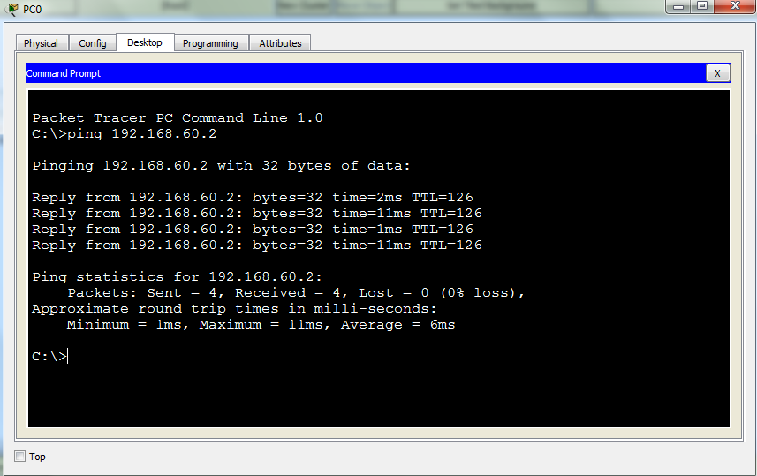

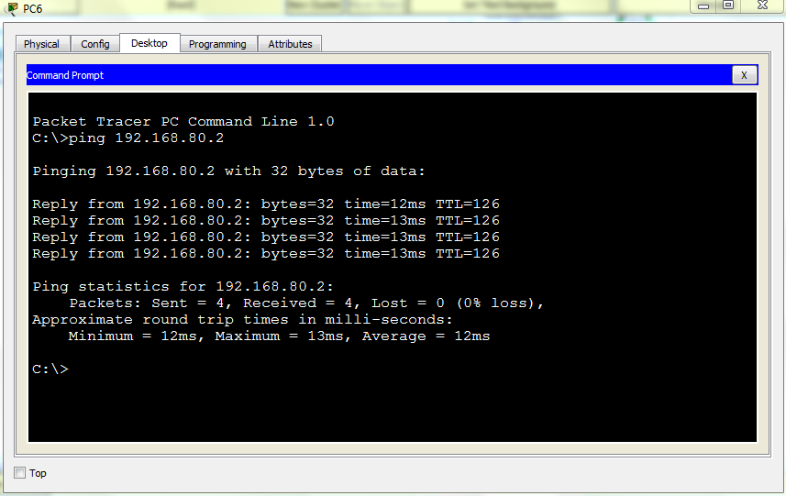

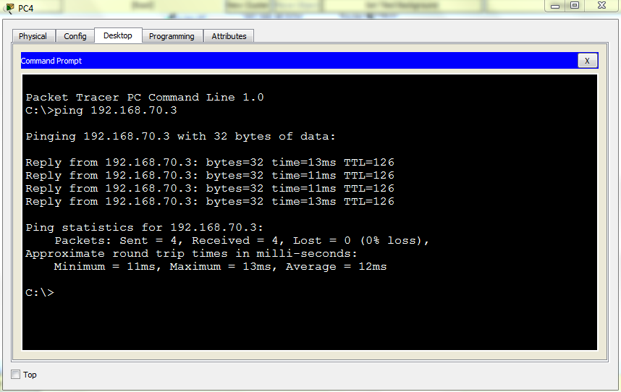

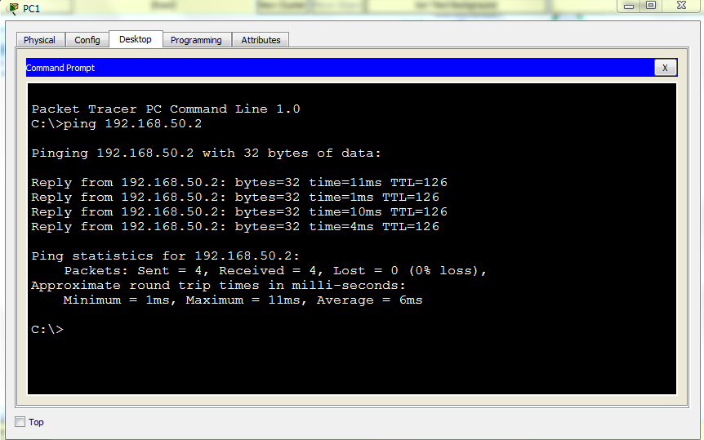

**End**